Walchand College of Engineering, Sangli
Department of Computer Science and Engineering
Final Year
Year: 2025-26 Semester: 1

Course: High Performance Computing Lab
Practical No. 4
Exam Seat No: 22510054
Title of practical:
Study and Implementation of Synchronization

Problem Statement 1:

Analyze and implement a Parallel code for below programs using OpenMP considering synchronization requirements. (Demonstrate the use of different clauses and constructs wherever applicable)

Fibonacci Computation:

Screenshots:

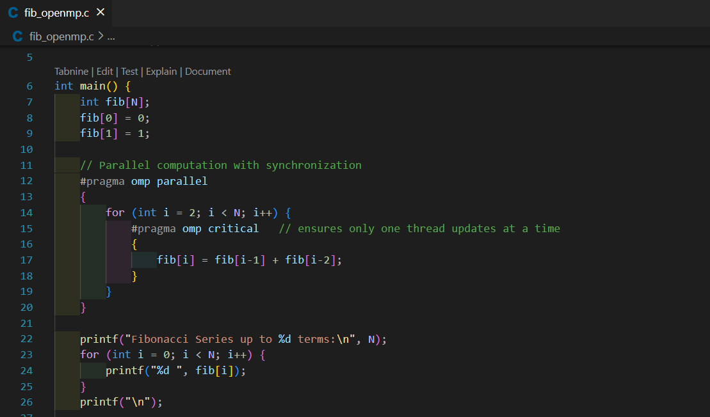

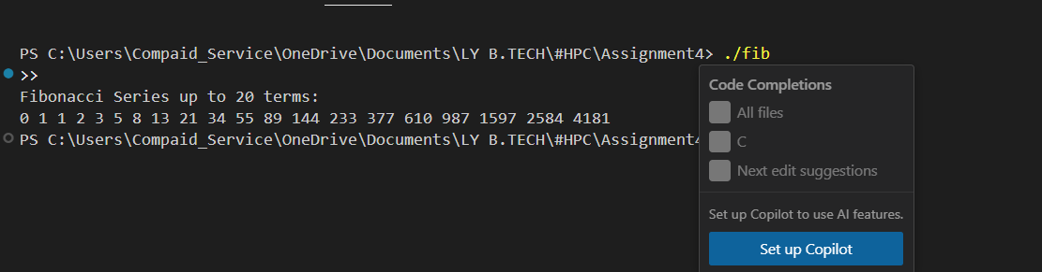

Information:
Problem Statement 1: Fibonacci Computation with Synchronization
Problem Description
Fibonacci is a sequence where each number is the sum of the two before it.
It starts with 0 and 1.
Formula:
- F(0) = 0
- F(1) = 1
- F(n) = F(n−1) + F(n−2), for n ≥ 2
Example:
0, 1, 1, 2, 3, 5, 8, 13, 21 …

Parallelization Goal
The idea is to calculate Fibonacci numbers in parallel using OpenMP. While doing this, we also need to handle synchronization so that threads don’t interfere with each other.
- In the recursive version, calls like fib(n-1) and fib(n-2) can run at the same time, so we use OpenMP tasks.
- In the iterative version, values are built step by step, which is more dependent, but we can still use OpenMP with synchronization to avoid mistakes.
This helps us understand how OpenMP clauses like critical, single, task, and taskwait are used.

Why Synchronization is Needed
In the loop version, each Fibonacci number depends on the previous two.
- If two threads update or read shared data at the same time, a data race may occur.
- Synchronization ensures correctness while still allowing parallelism.

OpenMP Tools Used
- critical → ensures only one thread updates at a time.
- single → only one thread executes a block while others wait.
- task → creates independent units of work for recursive Fibonacci calls.
- taskwait → ensures tasks finish before combining results.
- flush → makes memory updates visible to all threads.

Problem Statement 2:

Analyze and implement a Parallel code for below programs using OpenMP considering synchronization requirements. (Demonstrate the use of different clauses and constructs wherever applicable)

Producer Consumer Problem

Screenshots:

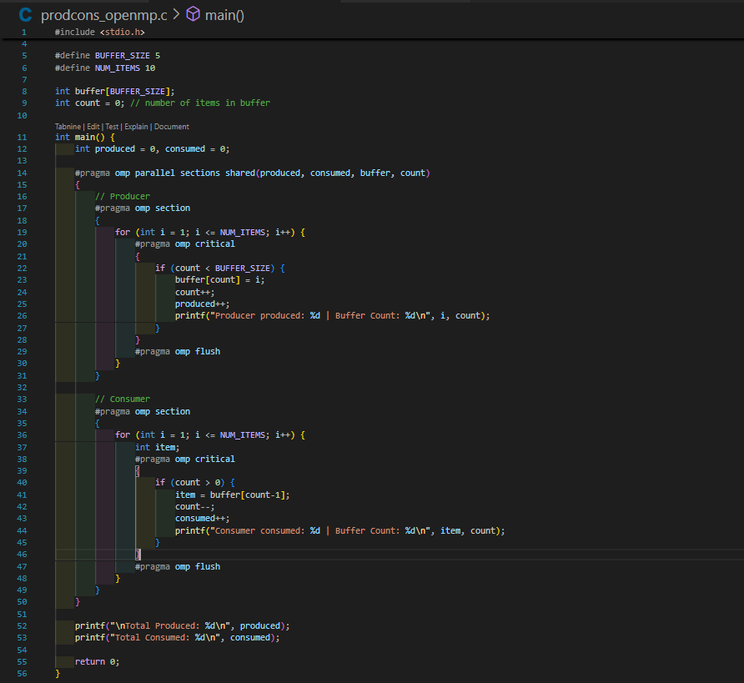

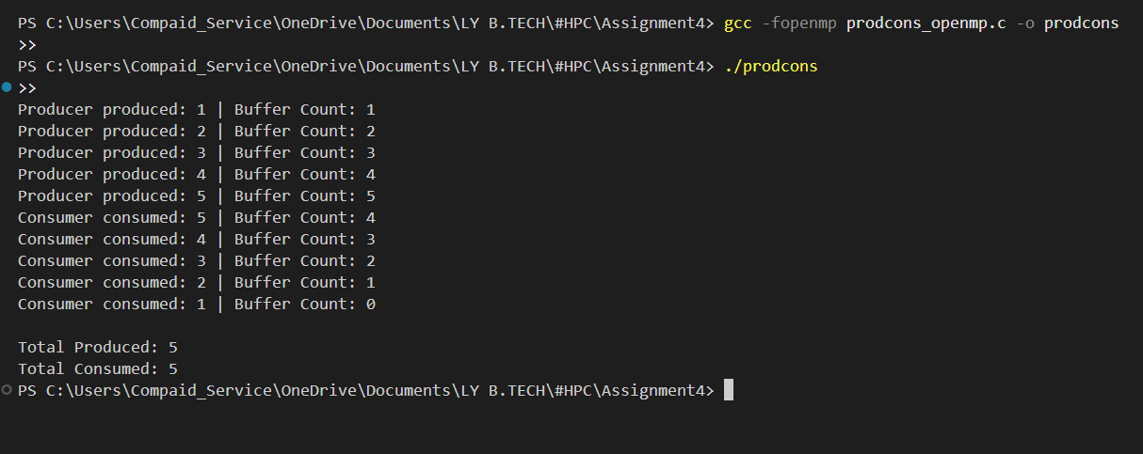
Information:

Problem Description
The Producer–Consumer problem is a classical synchronization problem where:
- The Producer generates data (items) and places them into a shared buffer.
- The Consumer takes data from the buffer and processes it.
Both must work together without conflicts:
- Producer should not add items when the buffer is full.
- Consumer should not consume when the buffer is empty.

Parallelization Goal
We want to implement the Producer–Consumer problem using OpenMP where one thread acts as Producer and another as Consumer.
- Multiple threads may try to access the shared buffer at the same time.
- Proper synchronization is needed to avoid buffer overflow, underflow, or data corruption.
- OpenMP sections can be used to run Producer and Consumer in parallel.

Why Synchronization is Needed
- Since both Producer and Consumer share the same buffer, race conditions can occur.
- If Producer and Consumer try to update the buffer index simultaneously, data may get overwritten or lost.
- Synchronization ensures mutual exclusion and maintains the correct order of production and consumption.

OpenMP Tools Used
- critical → ensures that only one thread accesses the buffer at a time.
- sections → divides the work so one thread runs Producer, the other runs Consumer.
- flush → makes sure updates in memory are visible to all threads.
- barrier (optional) → makes threads wait until both Producer and Consumer reach a safe point.

Github Link: https://github.com/veddnd/HPCprac4

